Index

- Introduction - Contributors, Initial Discussion, Domain Finalization
- Problem Statement – Setting Objective/ Outcome, Preparing Dataset
- Scope Definition – Scope of Implementation & Functionality
- Research/ Discussion - Implementation Plan
- Architecture – System Design, Components
- Testing & Validation- Metrics & Score
- Enhancement Opportunity -
- Conclusion -

Introduction

Contributors
Nishchay Tiwari tiwarinish92@gmail.com
Sivaswamy Akilesh akilesh10a@gmail.com
Jaydeep Kumar kumarjaydeep09@gmail.com
Shivanshu Soni
Lalith Kumar
Arindam Nag arindamng@gmail.com | Documentation
Shivaj More

Initial Discussion

Since most of us from retail & commerce background we decided to finalize the domain as Ecommerce. Alongside, we also decided skillset wise distribution of research. Based on our research current problems in market is more related to searching product, hence the finalized outcome from the project shall be a system which executes set of task based on context.

Problem Statement

Current commerce assistants operate in silos—treating text, images, and data as isolated inputs. This lack of "multimodal reasoning" leads to inaccurate search results and erroneous billing that erodes user trust. Also this way of search impacts
- Product discoverability
- Click per Task
- Turnaround time
- User Satisfaction Score
- Scope of error since steps count per task is more

User shall be enabled to find product by entering any languages and images. System shall be equipped with translation and image search functionality to handle above metrics and concerns.

Setting Objective/ Outcome

Following up the discussion it’s been found that current challenges in the industry we are involved with is Users dissatisfaction with intended product search & recommendation system.
Hence we finalized to set Business objective of this project is to
- Enable users to search product in multiple way
- Followed up by deciding the next step between Cancellation / Billing / Translator / Order / Refund etc.

To achieve this we have to
- Enable system to take text & Image input
- Assisted search for the user from LLM & stored data set
- Convey the output of the user actions to agents to decide further transactional event
- Maintain guardrail
- Test & validate

Preparing Dataset

For training the dataset we prepared is comprised of the product image related to retail items for training the LLM for the image search.

Scope Definition

Scope of Implementation

As defined scope the system will be able to
- Take input in Text or Image form
- Diverge input to Text LLM or Image LLM
- Set context of the prompt for the user
- Based on the intent of the of the user received from the prompt decide next course of action by sending execution of workflow to particular agent
- Retry / Fall back will be occurred based on confidence score
- Check Metrics/ score of the system
Scope of Functionality

AS per discussion functionality of this system will be limited to set of images with which the model is trained for image related search and Cancellation / Billing / Translator / Order / Refund Agents will be implemented.

Research/ Discussion

Implementation Plan

- Train Resnet50 with the data set
- Store data to FalkorDB
- Build UI with Streamlit to Take input in Text or Image form
- Agent to redirect workflow to Text LLM or Image LLM
- Set context of the user query by accessing LLM’s output
- Guardrail validation implementation
- To keep human in the loop build UI for receiving user’s prompt
- Talking to LLM for setting up the goal based on the intent of the of the user received from the prompt
- Building agents to handle directions from the retry & fall back loop
- Redirect the execution of workflow to particular agent
- Check Metrics/ score of the system

Challenges

As we progressed found challenges for >> Challenges shall be included

Architecture

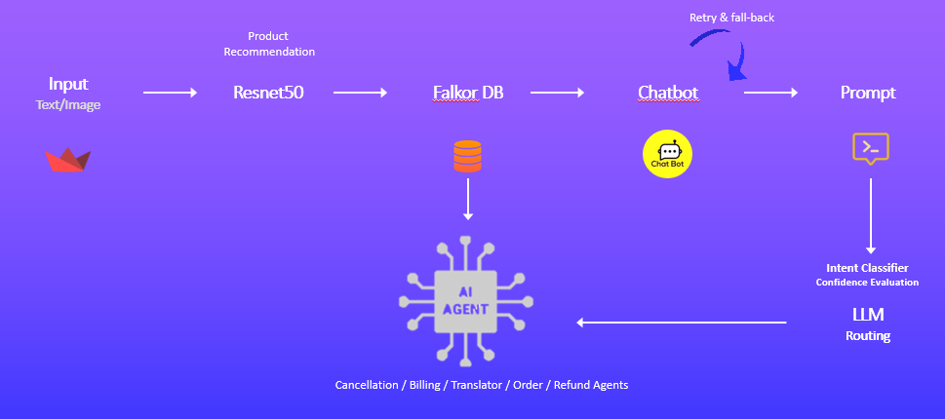

Agentic Multimodal Commerce Platform

Logical Components

- Agentic orchestration
- LangGraph Control flow
- Multimodal RAG
- Confidence-aware automation
- Guardrails

Tech Stack

- Python
- Streamlit
- LangGraph
- Falkor DB
- Open LLMs and embedding models

Execution Flow

- Streamlit is the entry point into the system. Here user will enter text or image.
- Conversation Manager Agent will maintain session state & redirect to Lang graph routing
- Guardrail validates inputs | enforce product/policy rules | confidence thresholds for automation
- Intent classifier distinguish text query vs image scan and downstream branches
- Interacting with LLMs
  - Text retrieval component will handle Multilingual query embedding as well as semantic search in FalkorDB by ranked candidates. For text embedding Sentence-Transformer is used.
  - Vision search will handle Image embedding &does similarity search in FalkorDB for the image input For image embedding CLIP / SigLIP is used.
  - FalkorDB is used to store text/ image embeddings & multilingual vectors
- Vector-based RAG is implemented to enhance the functionality of the product search
- Translation module will Normalize text to a canonical language for search and responses
- Billing & validation module will handle post transaction events with the help of agents
- Explanation module will carry out the explainability of the action taken by agents and for invalid ask

Testing & Validation

Enhancement Opportunity

Conclusion

